# Memory Allocation for Objects

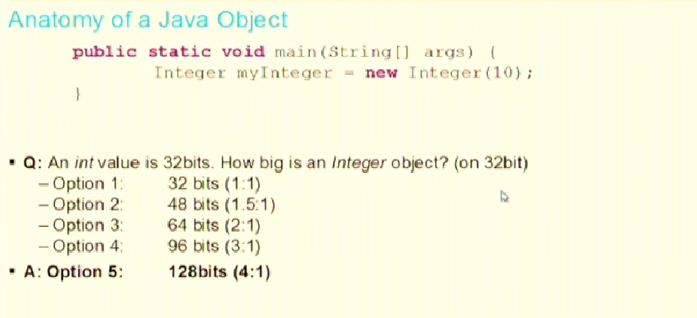

Java Objects have object-metadata which describes your object:

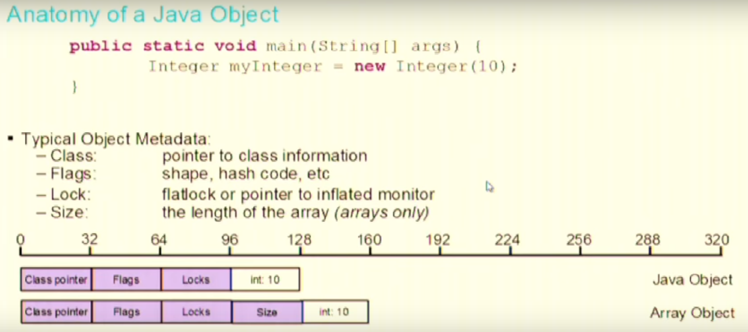

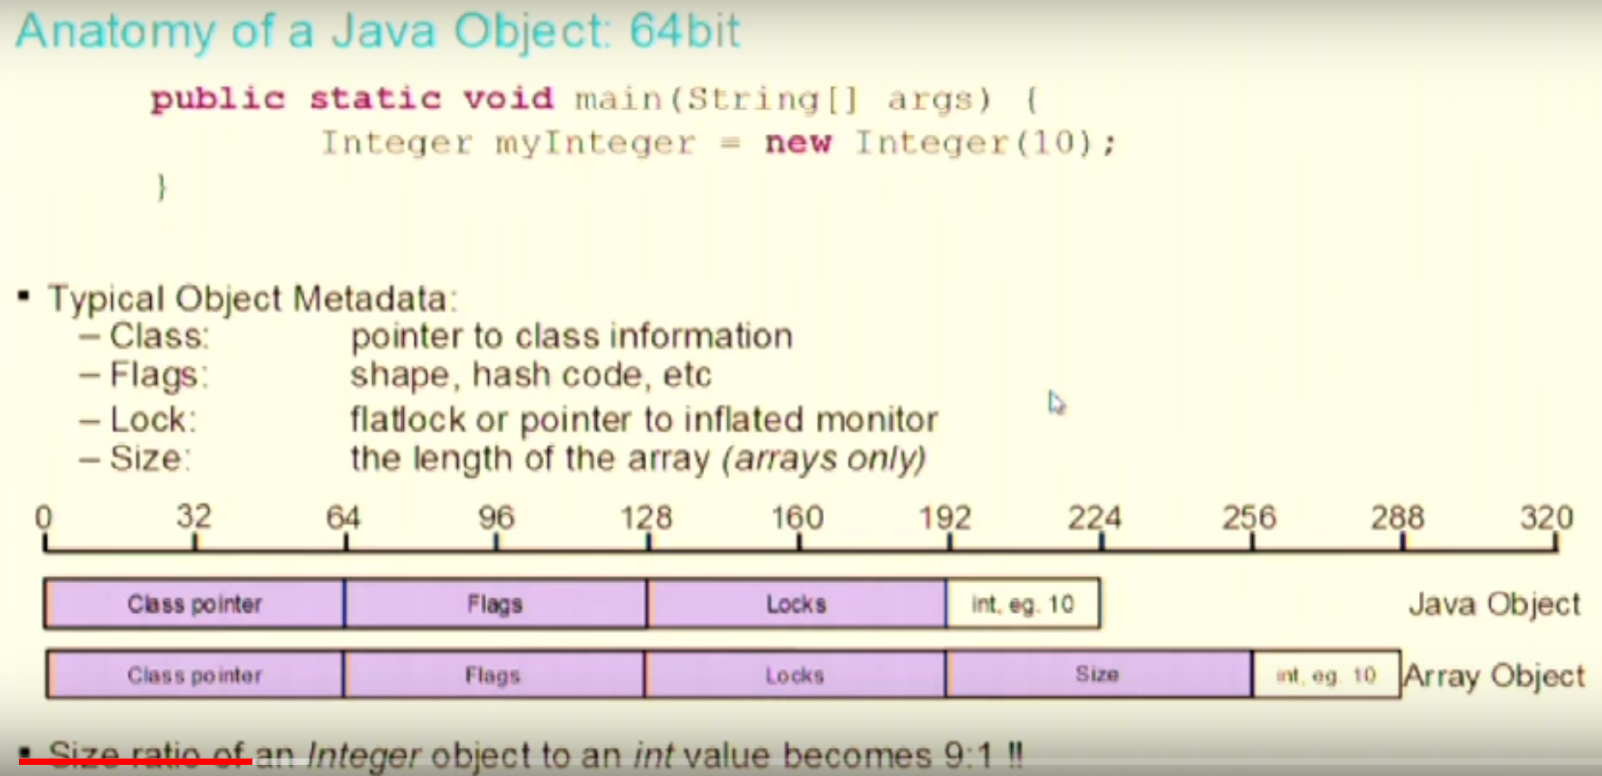

So when you move to 64 bit JVM is consumes more memory for the same object.

A way to get around is:

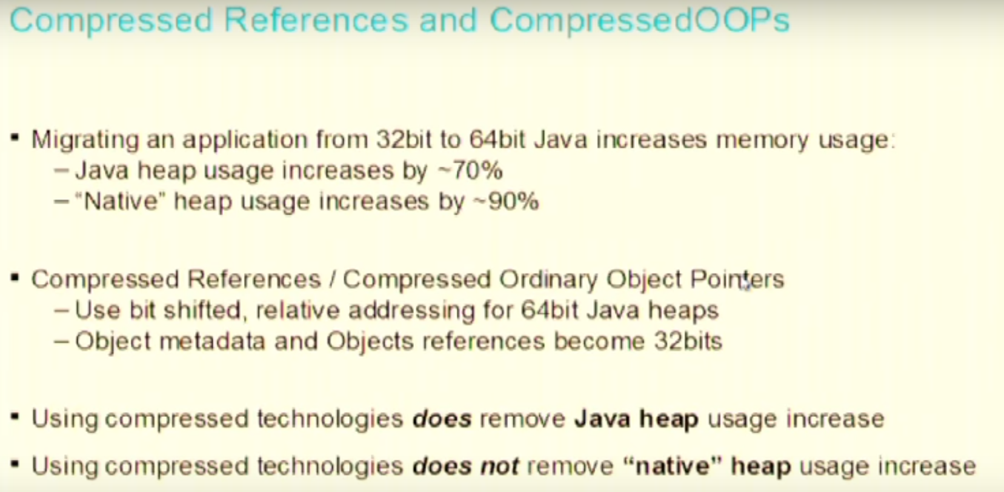

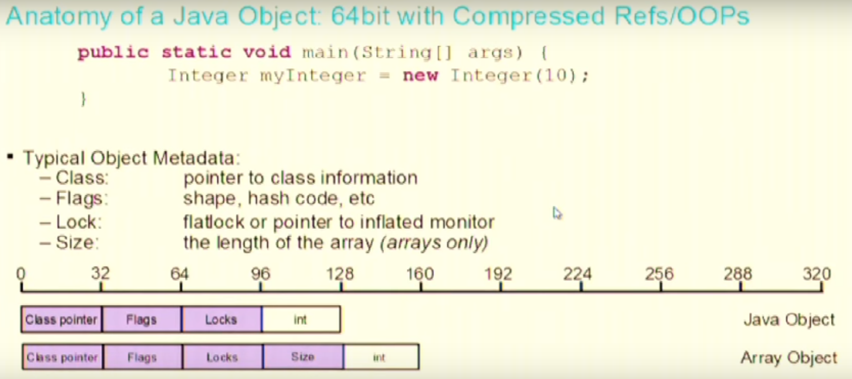

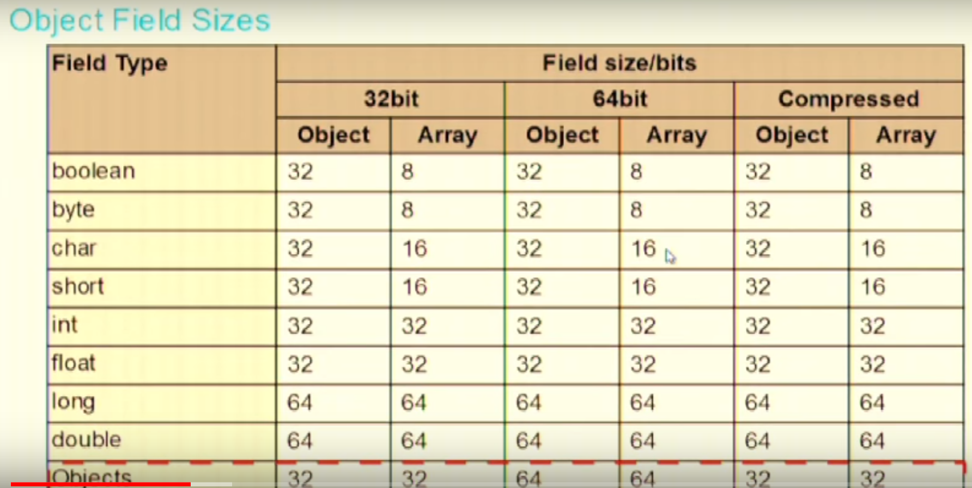

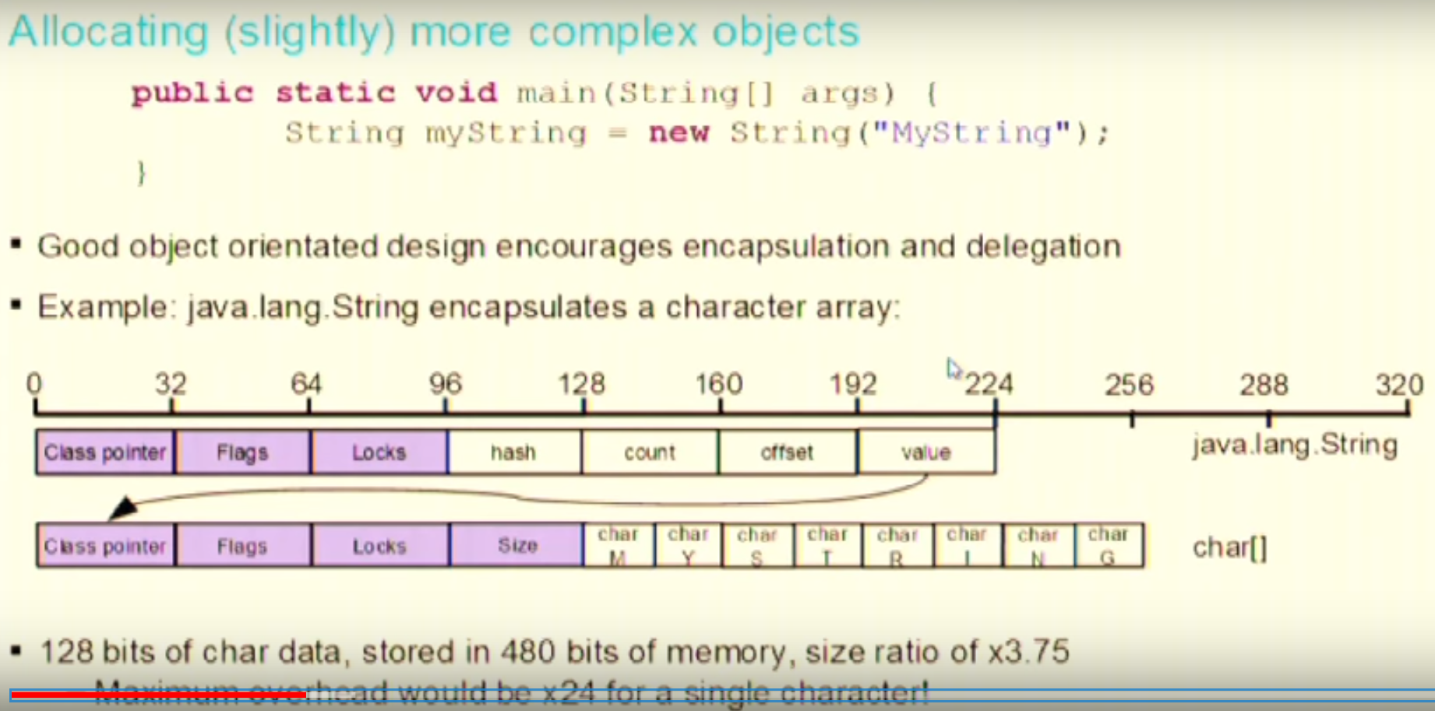

So if you have to store a char then store it as a single character, don’t wraps it as a String object.

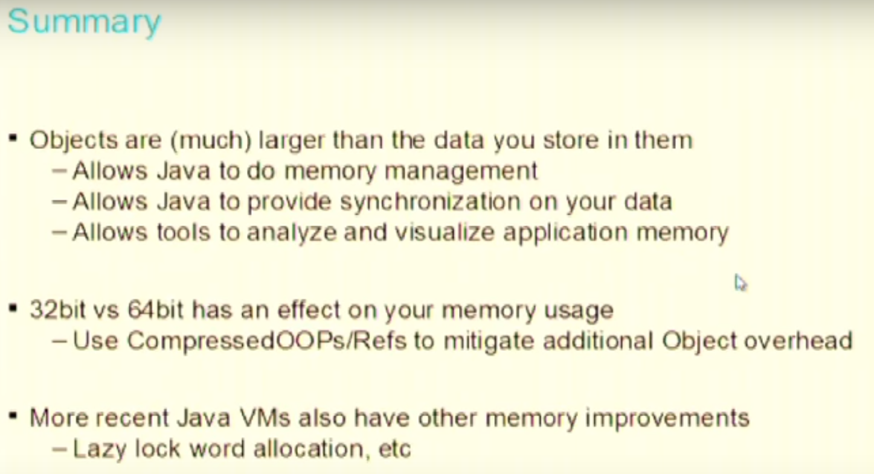

# Object Allocation and Garbage Collection

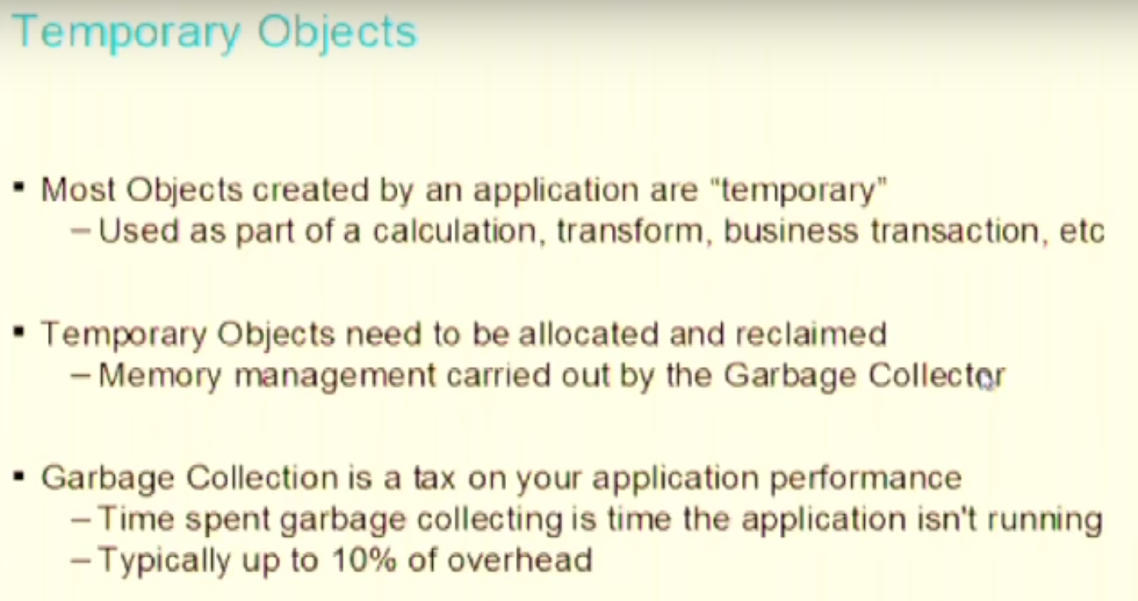

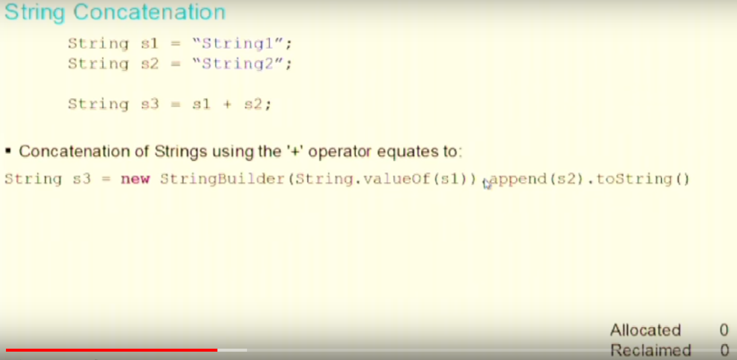

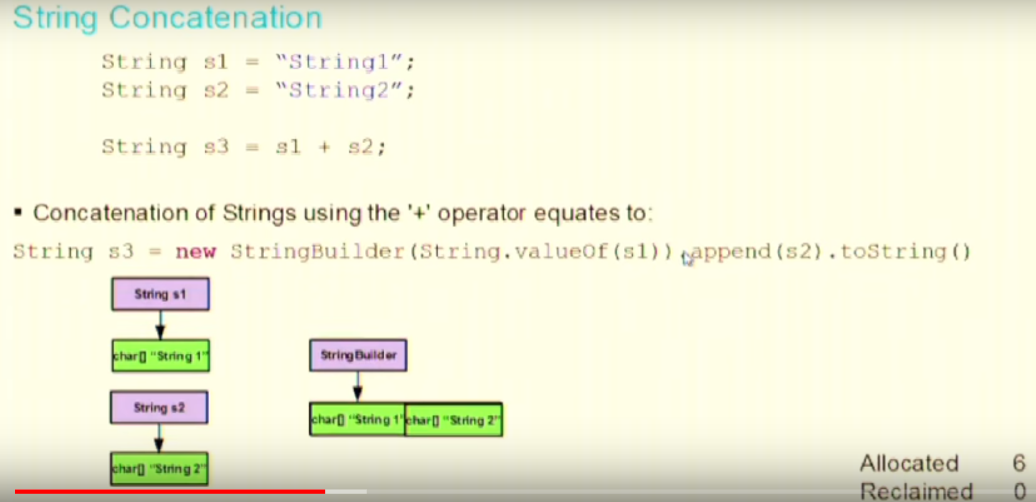

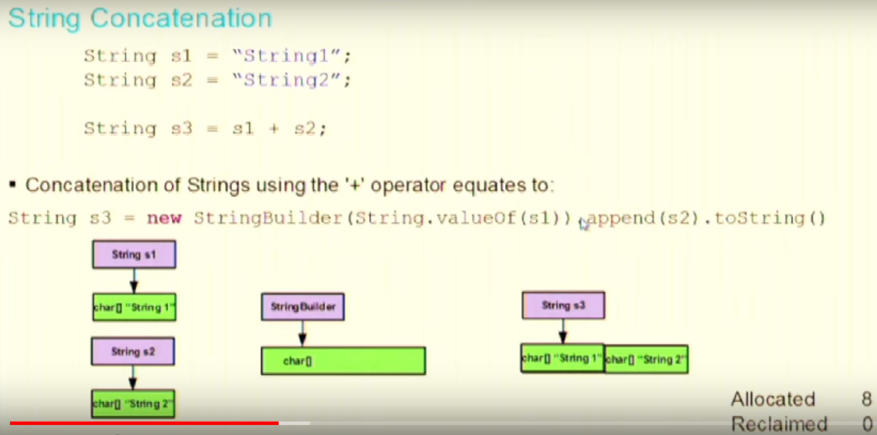

In the above steps we can see that to do String concatenation we created 8 objects. After concatenation is done we do not need 6 objects (2 for s1, 2 for s2 and 3 for String Builder)

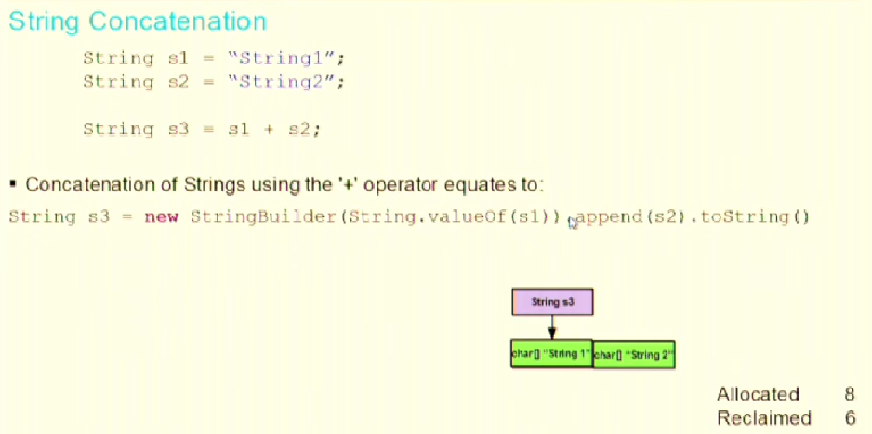

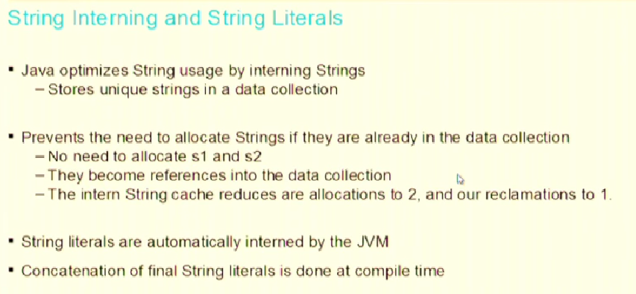

String literals are String initialized with “” while declaring the variable.

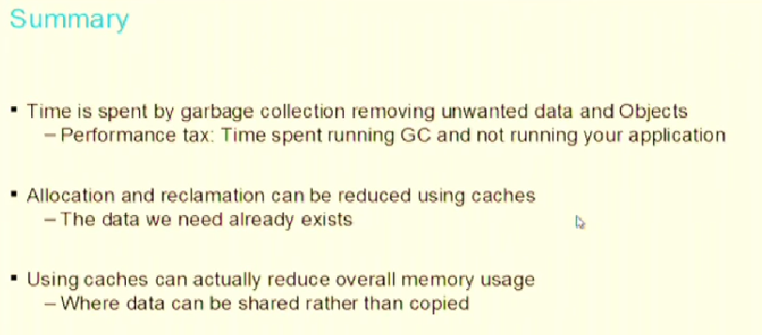

# Object Caching

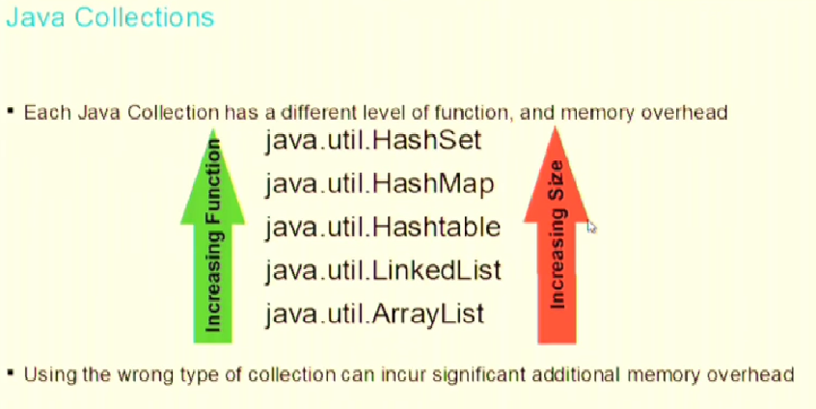

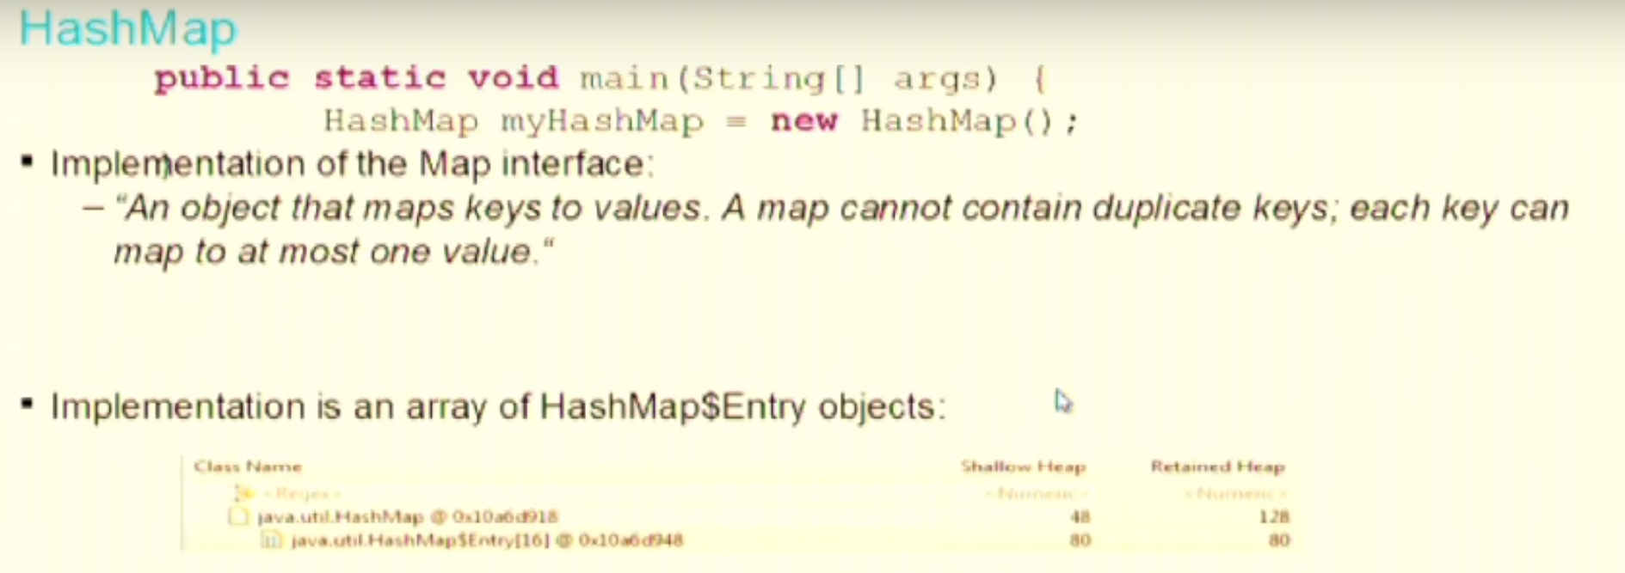

You can specify the size of HashMap while creating it. But if you do not specify then the default size is 16. Therefore, JVM will create an array of HashMap$Entry of size 16.

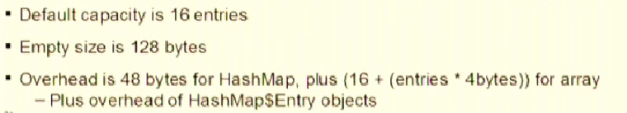

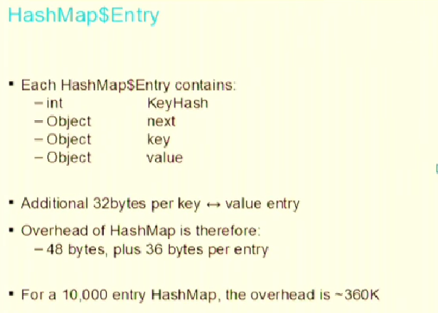

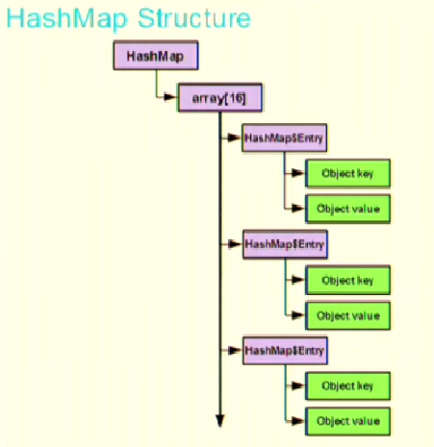

For every hashMap.put()

More data you put in HashMap more efficient it becomes in terms of memory usage.

For a HashMap default size is 16.

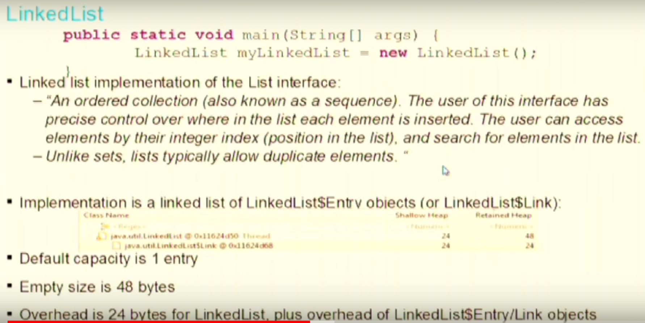

Linked list are more memory efficient than HashMap but not with performance.

For a Linked list default size is 0.

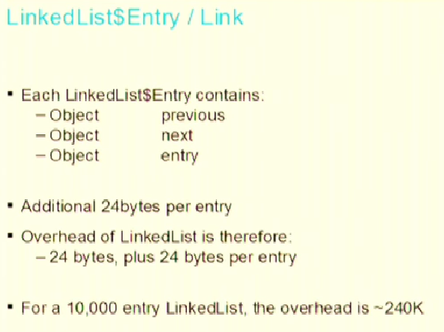

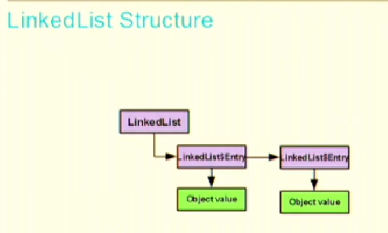

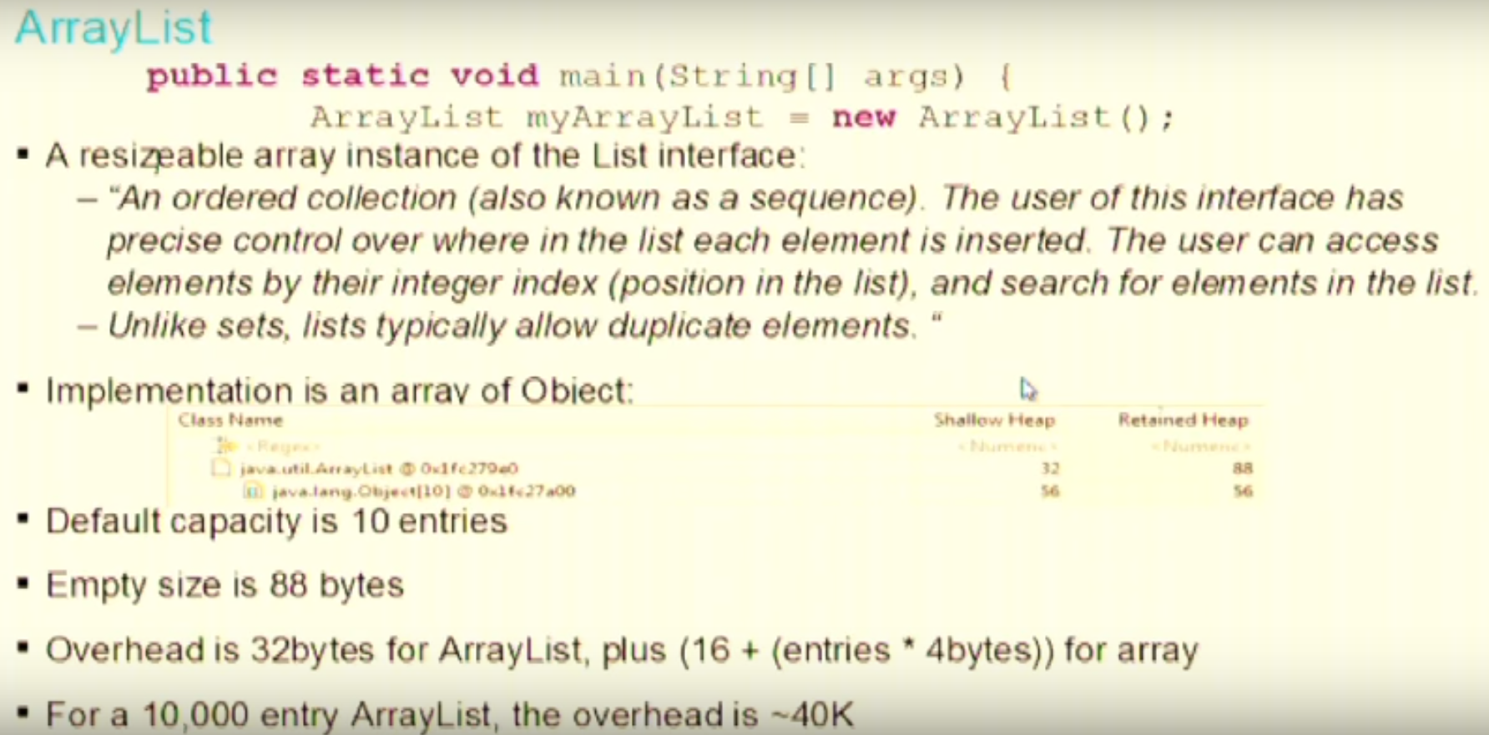

It is more memory efficient than HashMap and Linked List.

It can store lot of data and less meta-data (overhead).

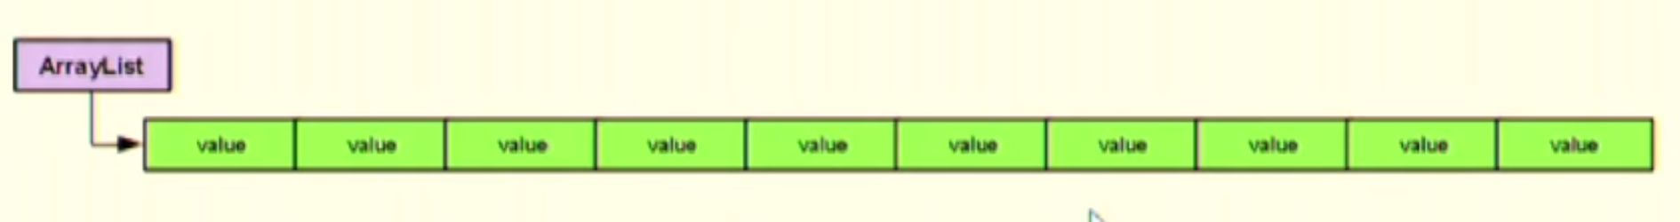

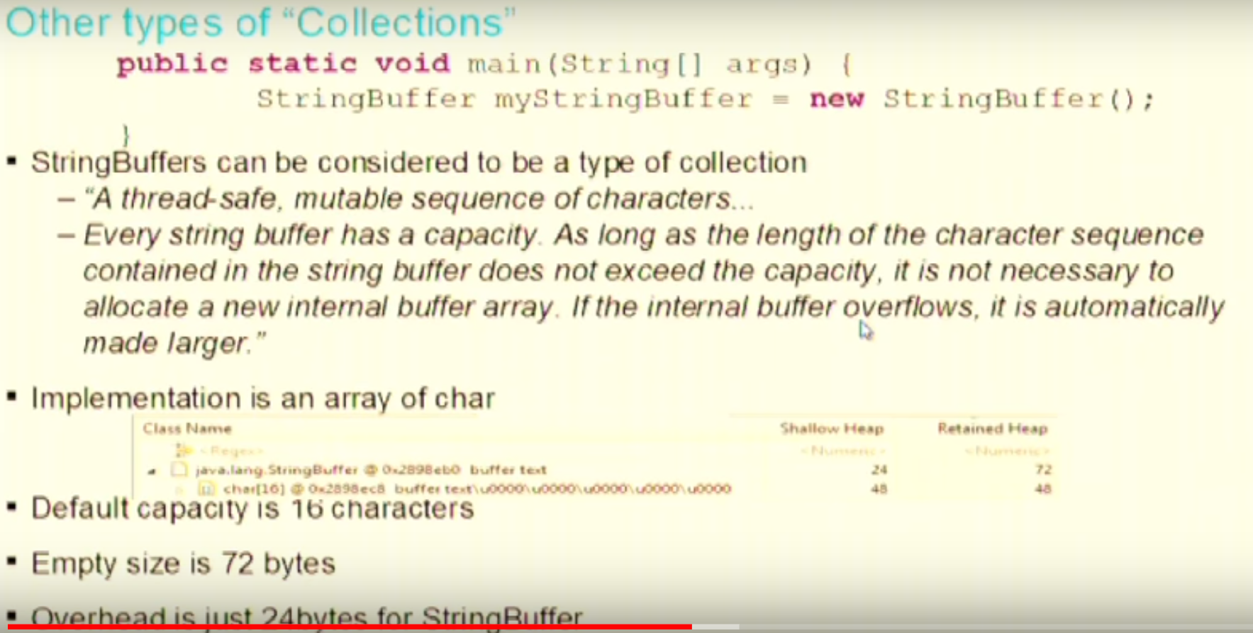

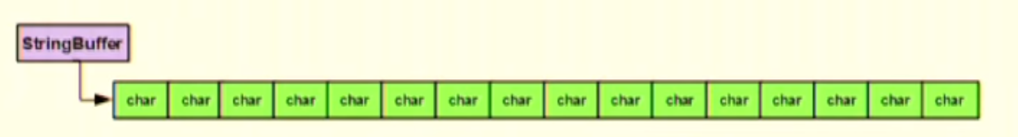

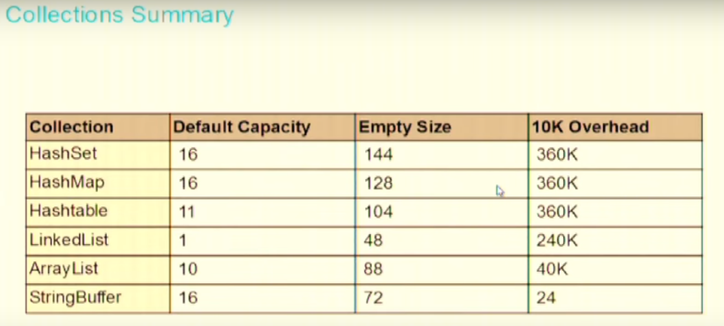

Due to more Overhead and poor performance Linked List are worth not using.

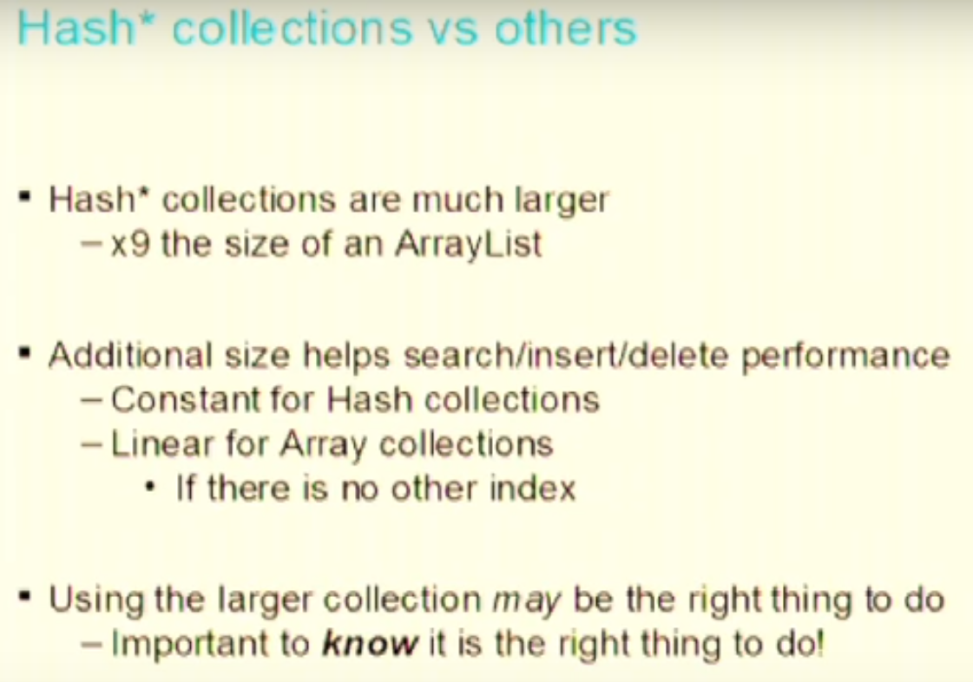

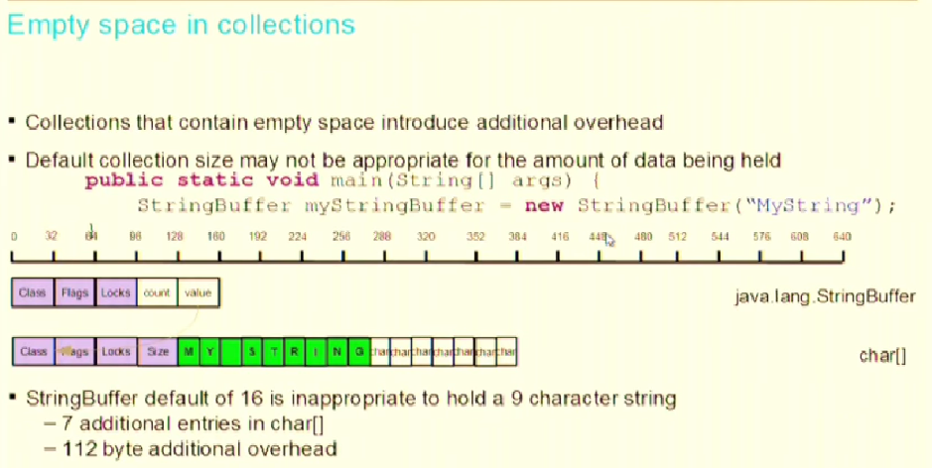

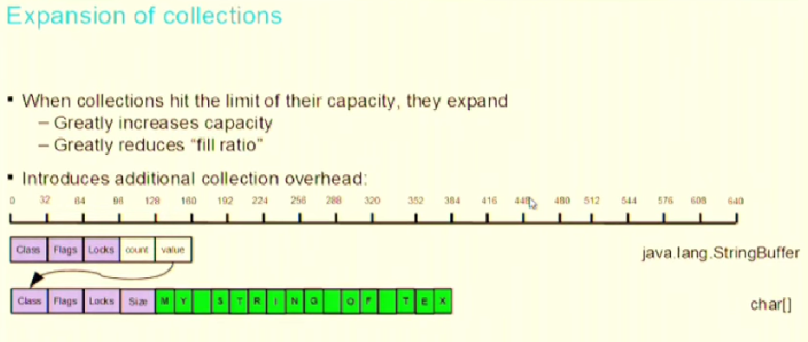

In order to put ‘T’ String Bugger has to string. It double in size of the original size the string is i.e. from 16 to 32. If there would have been 16 MB of data and then to just add 1 character it would add 16 MB more.

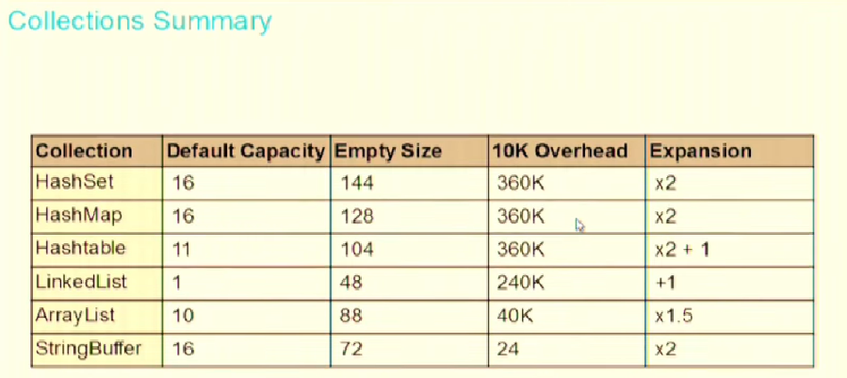

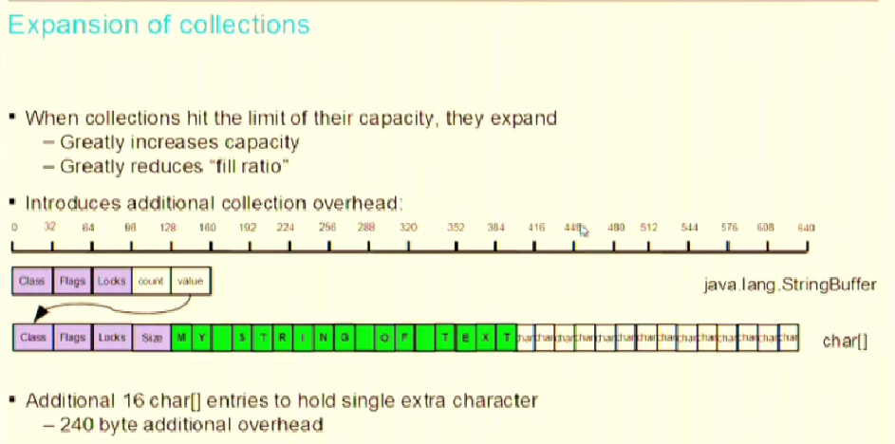

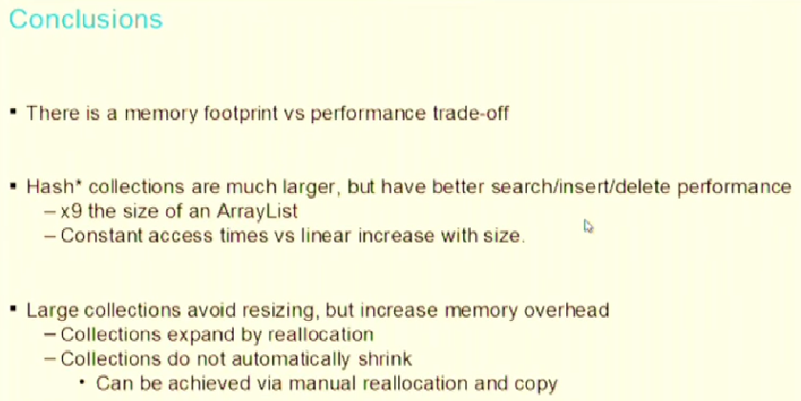

Try to size your collection correctly while creating it. If you know the size before hand then initialize it with that size. It will do two things:

1. Prevent waste-age of memory
2. Save time to resize thus improving performance

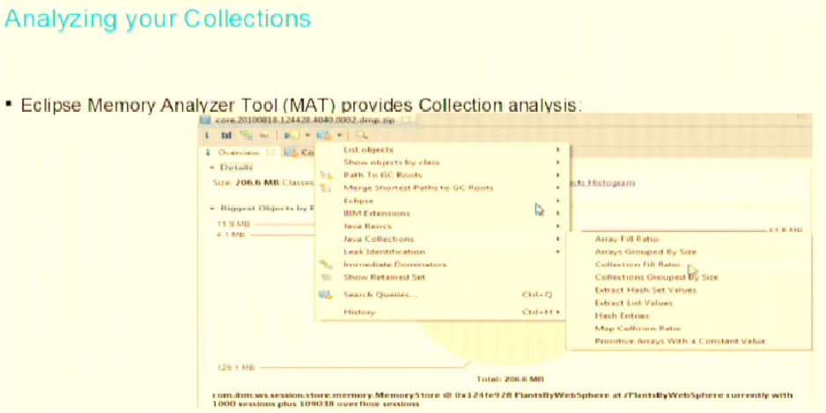

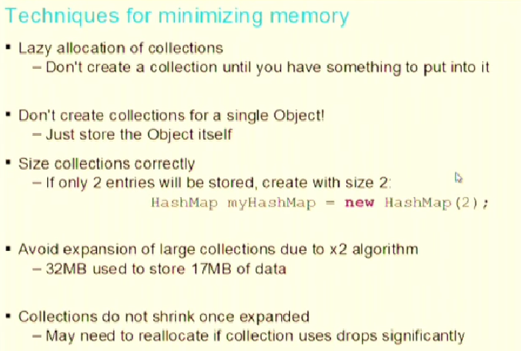

To increase size of an ArrayList or Array JVM creates a new object with increase size and then copies the data from old arrayList to newly created AL

# JVM Internals

Overall View

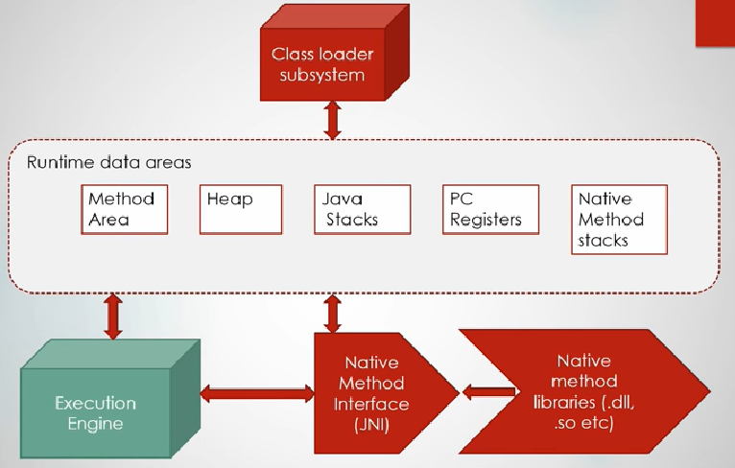

Class Loaders

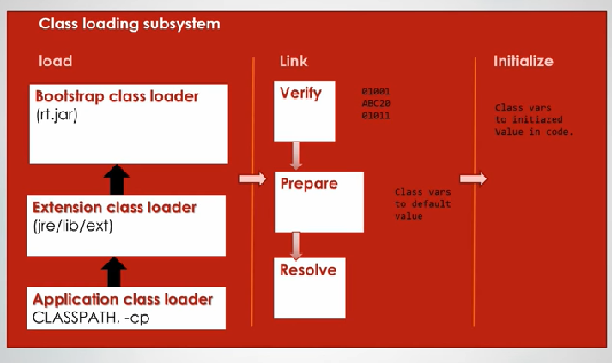

## Run-time Data Areas

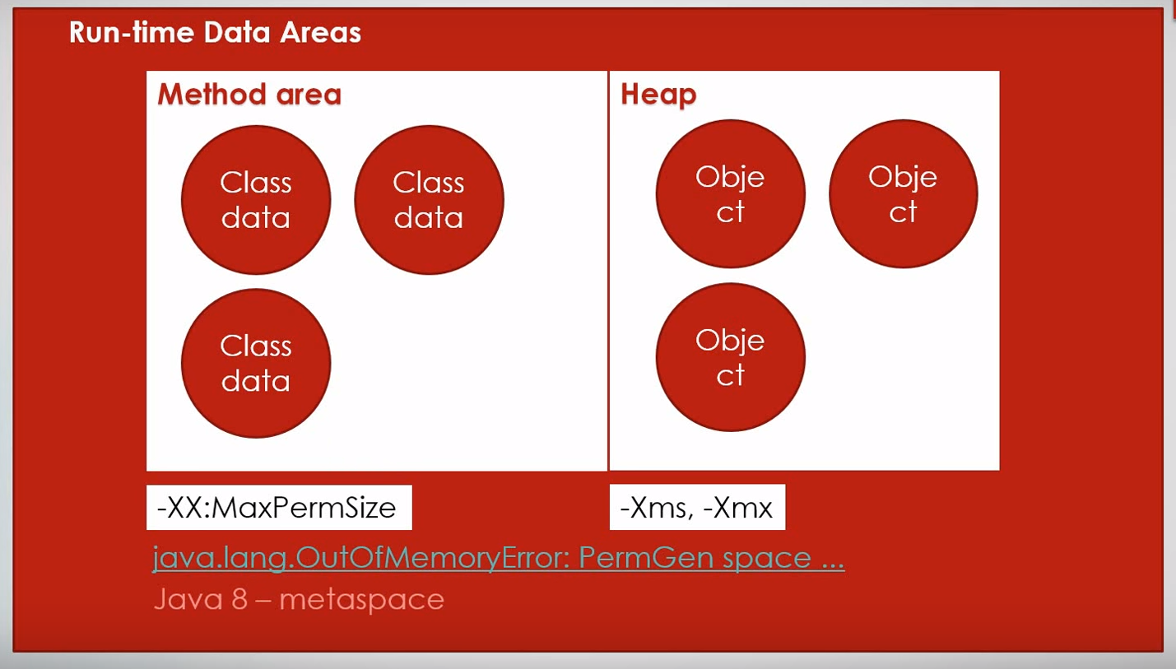

**Method area** = Permgen Space – stores the metadata (class data) for the classes. Lot of APIs like Reflection APIs enquire data in the Method area. Class data like:

* Static variables
* Byte code of the class
* Constant Pool

Default space for Permgen is 64 MB which is allocated out of JVM’s allocated space. This can be tuned using JVM arg -XX:MaxPermSize

**Metaspace** is not allocated from the memory space allocated to JVM, instead it is allocated from OS memory. Now by default there is no limit to Metaspace, but it can be limited as well using some JVM argument.

**Heap** – Stores object data. Everytime you instantiate an object, JVM stores it on the heap. It stores:

* Instance objects
* Arrays (since they are objects)

Heap can be sized by using -Xms (Min Size) and -Xmx (max). Be default ms = ¼ of total space allocated to JVM.

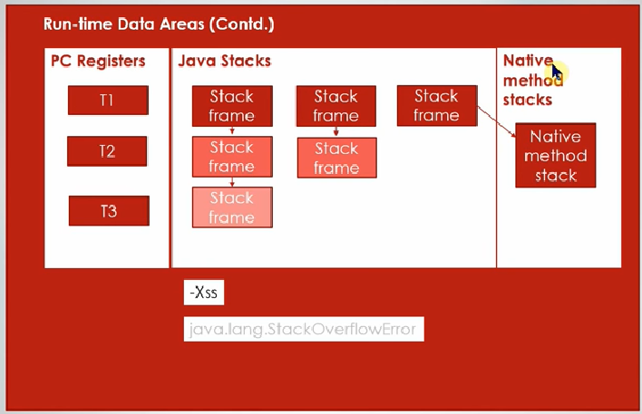

For T1

For T3

For T2

**PC Register** – Program Counter register. PC is the pointer to the next instruction to be executed per Thread. In this case T1/2/3 – will point to next instruction for Thread T1/2/3

**Java Stack** – Contains the stack frame corresponding to current method execution per thread.

**Stack Frame** – contains data related to currently executing method like:

* Address of the parameters and arrays
* Local variables within a method
* Return value
* Operand stack (scratch area for operations specified in method)

When stack area runs out of area JVM throws java.lang.StackoverFlowError

Thread’s cannot see each other’s stack area.

But Permgen/Metaspace and Heap are not for each Thread.

## Execution Engine

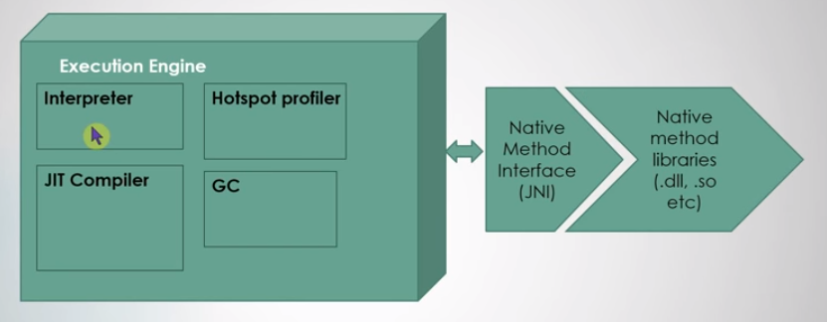

**Interpreter** – interprets the instruction in the byte code and finds out what native operation has to be done and executed that native operation. It is done by using JNI (which used native method libs).

**JIT Compiler** – Suppose if some instructions are getting executed repeatedly then JIT compiler will not compile it again and again. It will

# Garbage Collector

Heap can be divided into:

= Old Gen

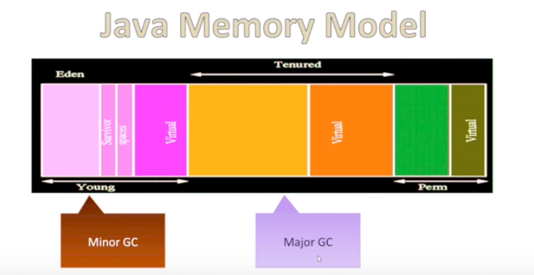

No GC happens here

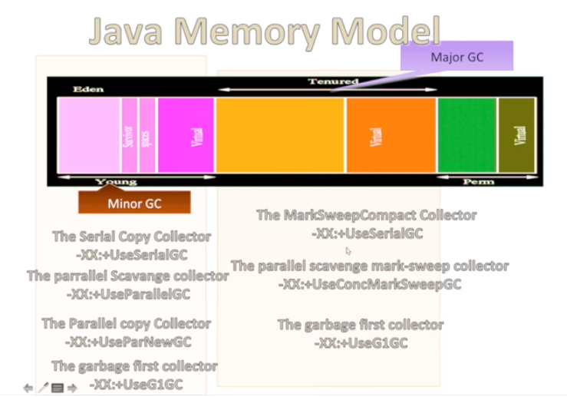

Command line args to pring GC:



